YEAR 6 Biology: How are living things similar and different? SCIENCE
Pye Bank CE Primary DSAT Knowledge Organiser
KEY VOCABULARY |  | KEY SCIENTIST – Carl Linnaeus  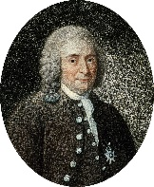  ‘God created, Linnaeus organised’: these are the bold words of 18th century Swedish scientist Carl Linnaeus. Linnaeus’s most-lasting achievement was the creation of the binomial (two-name) classification system.  In this system, each living thing is assigned a name consisting of two Latin words. The first word is the genus to which the subject belongs. The second name is the specific species within that genus. For example, the human species is known as Homo sapiens.  1707-1778 |  | KEY CONCEPT – Microorganisms
Animals: Living organisms that feed on plants or other animals and, typically, have nervous systems that enable them to respond to stimuli.  Biologist: A scientist who studies living organisms and how they relate to their environments.  Characteristic: Characteristics are features of living things which help scientists classify them.  Classification: Classification is the method scientists use to group living things.  Fungus: A fungus (plural fungi) is a living thing which breaks down dead matter around it, and uses it as food. Examples include mushrooms and toadstools.  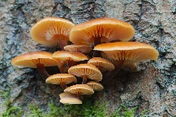  Kingdom: One of the five groups that many scientists use to classify living things.  Micro-organism: Micro-organisms are small living things, including bacteria and yeast.  Parasite: An organism that lives in or on another organism and benefits by feeding off it at its host’s expense.  Plant: A plant is a living thing which can make its own food. Examples include trees, ferns, mosses and flowering plants.  Species: A class of living organism that can breed with others of the same class to produce fertile offspring.  Virus: A virus is sometimes called a micro-organism but it is not classified as a ‘living thing’ because it needs a host organism to survive.  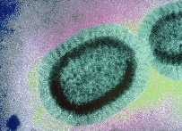 |  |  |  | 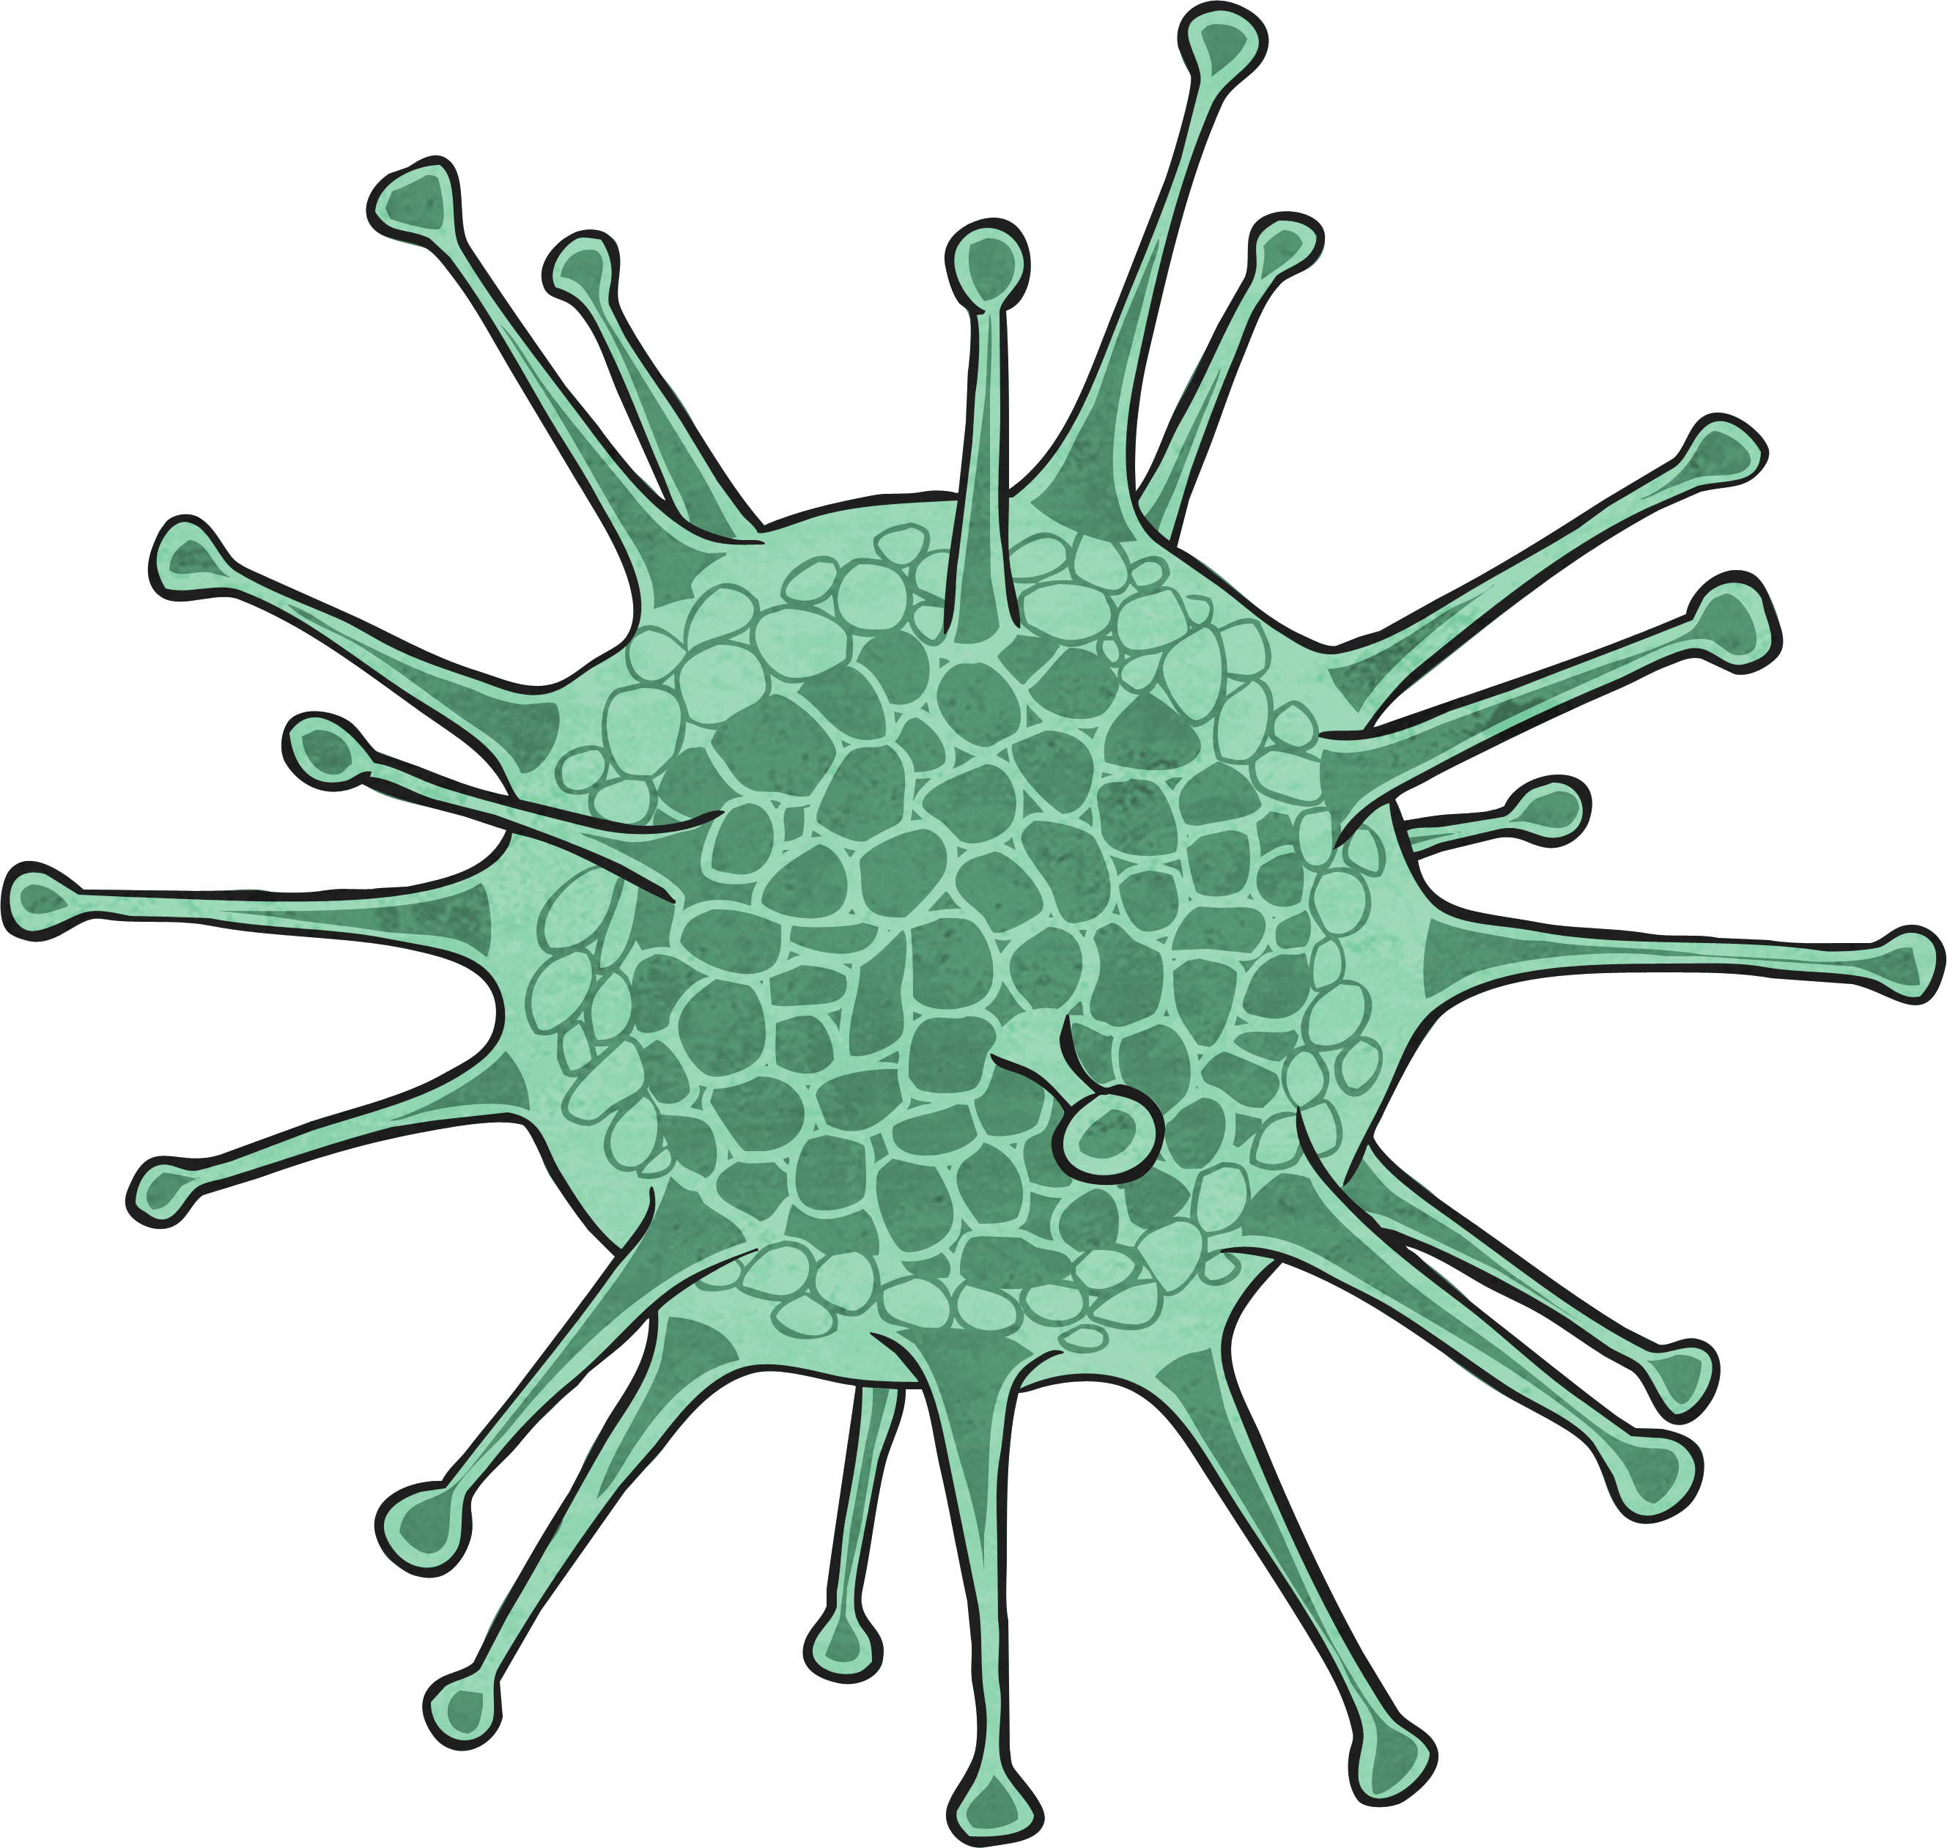  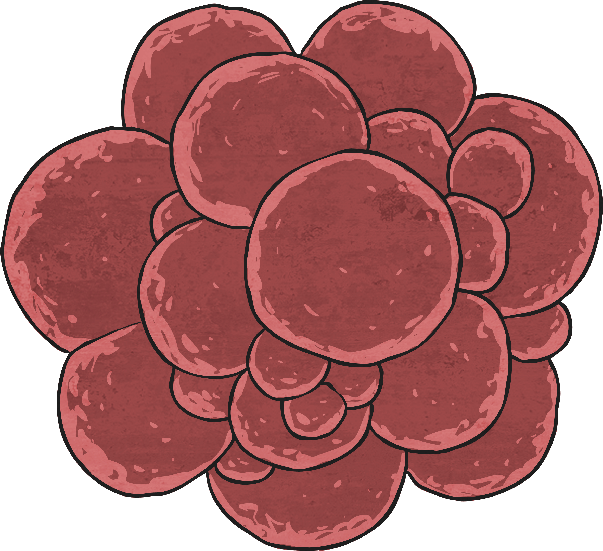  Microorganisms are also known as 'germs'. Harmful germs can make us unwell. Good hygiene will avoid spreading these germs. Use soap and hot water to wash your hands after preparing food or using the toilet. This will kill bacteria.  It may also help you to think of cells as small compartments that contain the things needed to keep an organism alive.  Microorganisms are tiny. They are so small they can only be seen with a microscope. Yeast is a helpful microorganism which makes bread rise. Bacteria is a microorganism which breaks down plants into nutrients.
 |  | STICKY KNOWLEDGE |  | KEY CONCEPT – Classification
 |  | - Classification involves placing living things into progressively smaller and smaller groups. These groups are kingdom, phylum, class, order, family, genus and species.  - Vertebrates have a backbone but invertebrates do not have one.  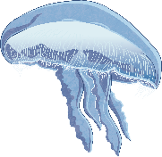  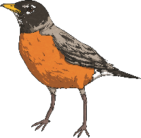  A jellyfish is an invertebrate  A bird is a vertebrate  - Plants can be divided into two main groups: flowering and non-flowering plants.  - Fungi do not make seeds like plants do. Instead, they produce fruit that contain tiny spores.  - New species are formed as a result of evolution over thousands of generations.  PHYSICAL CHANGES  PHYSICAL CHANGES |  | Branch keys involve a series of questions about an organism's physical characteristics, with the answers branching off to others until the organism is identified  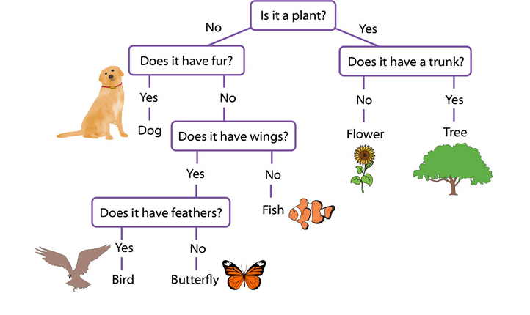  Can you identify the plant which does not have a trunk?

