YEAR 1 BIOLOGY: What are bodies and what can they do? SCIENCE
Pye Bank CE Primary DSAT Knowledge Organiser
KEY VOCABULARY |  | KEY CONCEPT |  | KEY CONCEPT
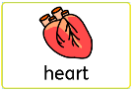  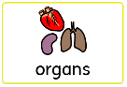  Organs – a group of living tissues that performs a specific function inside the body  Heart – a muscular organ that pumps blood around the body  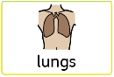  Lungs – a pair of organs that are within the ribcage that are stretchy to allow us to breathe in air and out carbon dioxide  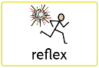  Reflex – involuntary movements of the body - automatic actions that your body does to respond to things without you thinking  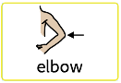  Elbow – a joint between your forearm and upper arm  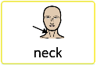  Neck – a part of the body that connects the head to the rest of the body  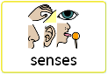  Senses – what our body uses to make sense of the world around us. There are five main ways: sight (with our eyes), hearing (with our ears), taste (with our tongue), smell (with our nose) and touch (with our fingers)  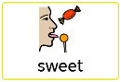  Sweet – a pleasant taste  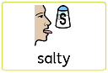  Salty – a type of taste that some people find unpleasant  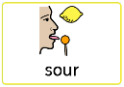  Sour – a sharp, sometimes unpleasant taste  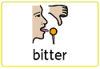  Bitter – an unpleasant taste  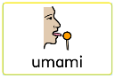  Umami – a taste that is neither sweet, salty, sour nor bitter. Umami foods have their own distinctive taste such as cheese, meat and vegetables. |  | 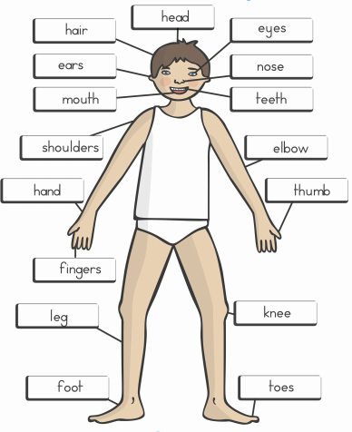 |  | 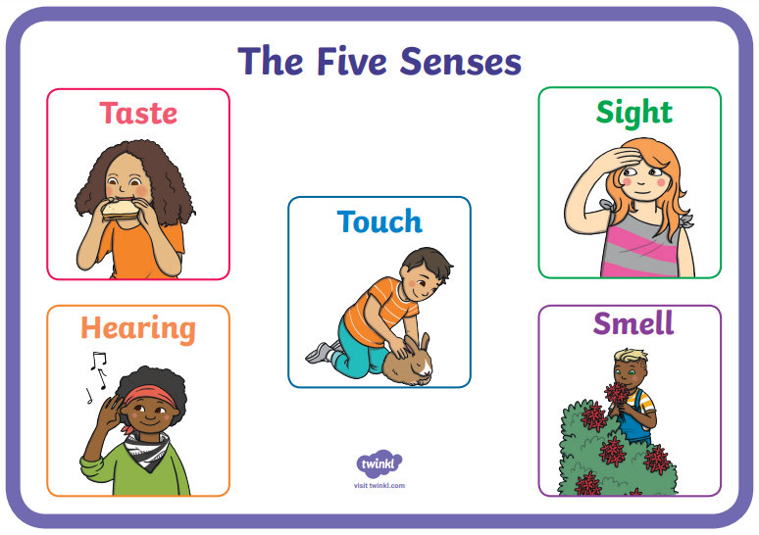  We have 5 senses that help us to understand the world around us. These are taste, hearing, touch, sight and smell. We use different body parts to help us to use these 5 senses.
 |  | STICKY KNOWLEDGE |  | KEY CONCEPT
 |  | - Each part of our bodies have their own name.  - Our five senses are working all of the time to help us to understand the world around us.  - Our bodies have organs inside of us that help us to live. |  | 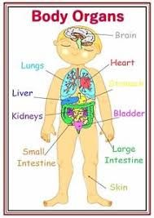  There are different organs inside of our bodies that help us to live. Each one has a different job that helps us to survive.

